SIMATS ENGINEERING (SAVEETHA SCHOOL OF ENGINEERING)
Department of Computer Science and Engineering
CO4 ASSESSMENT TOOL 1 – Test Case Design Assignment

Course Code: | CSA1017 | Course Title: | Software Engineering
CO Assessed: | CO4 | Assessment: | Assessment Tool 1 – Test Case Design Assignment
Weightage: | 20% | Total Marks: | 25
CO4 Statement: | Implement robust testing, quality assurance, and DevOps practices, emphasizing security, reliability, and ethics
Student Name: | SHAKTHIVEL R | Reg. No.: | 192524325
Date: |  | Duration: | 60 minutes

Code of Conduct
I __________________________ (Name / Reg No) certify that this submission is my original work and that I have adhered to the guidelines specified for this assessment. I understand that any violation of academic integrity rules will result in disciplinary action.
Signature of the Student: _________________________
Annexure A – Test Case Design Assignment
Instructions to Students:
Each student is assigned an individual problem statement. Based on the assigned problem statement, design and document comprehensive test cases to verify the correctness, functionality, reliability, and usability of the proposed system.
Your test case design should include:
- Identify the functional and non-functional requirements to be tested.
- Identify the test scenarios for the assigned problem statement.
- Prepare detailed test cases covering normal, boundary, invalid, and exceptional conditions.
- Include Test Case ID, Test Scenario, Test Steps, Test Data, Expected Result, Actual Result, and Pass/Fail Status.
- Apply appropriate test design techniques such as Equivalence Partitioning, Boundary Value Analysis, Decision Table, or State Transition Testing wherever applicable.
- Ensure that the test cases provide adequate requirement and functional coverage for the assigned system.
Deliverable: Submit a Test Case Design document containing the identified scenarios, test cases, test data, expected results, and test coverage based on the individual problem statement.

Rubrics for Calculation
Evaluation Criteria | Excellent (4 Marks) | Good (3 Marks) | Satisfactory (2 Marks) | Needs Improvement (1 Mark)
Requirement & Test Scenario Identification(15%) | Clearly identifies all relevant functional/non-functional requirements and comprehensive test scenarios | Identifies most requirements and scenarios | Identifies basic requirements and scenarios | Requirements/scenarios are incomplete or unclear
Test Case Design & Completeness(25%) | Comprehensive test cases covering normal, boundary, invalid, and exceptional conditions | Covers most important conditions with minor gaps | Covers basic conditions but misses several important cases | Test cases are very limited or incomplete
Test Data & Expected Results(20%) | Appropriate test data with precise, measurable expected results for every test case | Mostly appropriate test data and expected results | Some test data/results are unclear or incomplete | Test data and expected results are largely missing/incorrect
Application of Test Design Techniques(15%) | Correctly applies multiple techniques such as Equivalence Partitioning, Boundary Value Analysis, Decision Table, and State Transition | Correctly applies at least two relevant techniques | Applies one technique with limited justification | Techniques are not applied or incorrectly applied
Traceability & Test Coverage(15%) | Excellent mapping between requirements, scenarios, and test cases with strong coverage | Good traceability and coverage with minor gaps | Partial traceability and moderate coverage | Poor/no traceability and inadequate coverage
Documentation & Presentation(10%) | Well-structured, clear, professional, consistent, and easy to understand | Well-organized with minor presentation issues | Adequately organized but has some clarity/formatting issues | Poorly organized, unclear, or incomplete documentation

Criteria | Mark
Requirement & Test Scenario Identification (15%) | /5
Test Case Design & Completeness (25%) | /4
Test Data & Expected Results (20%) | /4
Application of Test Design Techniques (15%) | /4
Traceability & Test Coverage (15%) | /4
Documentation & Presentation (10%) | /4
TOTAL | /25

TEST CASE DESIGN REPORT
Project Title: Intelligent AI-Based Smart Aquaculture Disease Prediction and Feed Optimization System
1. System Overview
The proposed smart aquaculture system supports fish-farm monitoring by collecting water-quality and fish-related inputs, evaluating possible disease risk, and producing feed recommendations. A web dashboard presents measurements, predictions, alerts, and recommendations to the user.
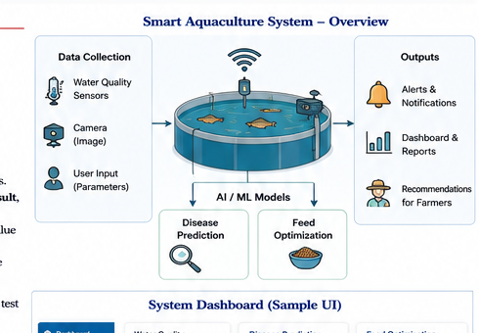
Figure 1. Generated smart aquaculture system overview.

Primary Functions
• Secure user registration and login.
• Entry and validation of pond water-quality parameters such as pH, temperature, dissolved oxygen, and ammonia.
• Fish-image upload and AI-assisted disease prediction.
• Feed optimization based on fish weight, age/growth stage, condition, and relevant pond information.
• Dashboard display of water quality, prediction confidence, recommendations, and alerts.
• Report generation for observations and system decisions.

2. Functional Requirements to be Tested
ID | Requirement | Acceptance Focus
FR01 | User registration and login | Valid users can access the application securely.
FR02 | Water-quality input | The system accepts valid pond parameters and stores them.
FR03 | Parameter validation | Out-of-range or missing values are rejected with a clear message.
FR04 | Fish-image upload | A supported image file can be submitted for prediction.
FR05 | Disease prediction | The system returns a disease class/risk and confidence value.
FR06 | Feed optimization | The system recommends feed type and quantity.
FR07 | Alerts | Risk conditions generate visible alerts.
FR08 | Dashboard | The dashboard displays current readings and recent results.
FR09 | Reports | The system generates a readable record of observations and outputs.

3. Non-Functional Requirements
ID | Requirement | Test Focus
NFR01 | Performance | Common operations should respond within an acceptable response time.
NFR02 | Reliability | Input failures should not crash the application.
NFR03 | Security | Unauthorized users must not access protected modules.
NFR04 | Usability | Messages and controls should be clear and consistent.
NFR05 | Availability | The service should recover gracefully after temporary sensor/API failures.
NFR06 | Scalability | The system should support additional ponds and users without redesign.
NFR07 | Privacy | Credentials and farm/user information should not be exposed in logs.
These requirements form the basis for the traceability matrix used later in the report.

4. Test Scenarios

Scenario ID | Scenario
TS01 | User registration with valid details
TS02 | Login with valid credentials
TS03 | Login with invalid password
TS04 | Water-quality input within normal range
TS05 | Water-quality input at boundary values
TS06 | Water-quality input outside accepted range
TS07 | Missing required sensor field
TS08 | Upload valid fish image
TS09 | Upload unsupported or corrupted image
TS10 | Disease prediction with normal image
TS11 | Disease prediction with suspected disease image
TS12 | Feed recommendation for healthy fish
TS13 | Feed recommendation for diseased fish
TS14 | Sensor/network failure during dashboard refresh
TS15 | Generate report from stored observations
TS16 | Unauthorized attempt to access prediction page

5. Test Design Techniques

• Equivalence Partitioning: split input values into valid, invalid, and missing classes.
• Boundary Value Analysis: check minimum, maximum, just-below, and just-above accepted values.
• Decision Table Testing: validate feed recommendations across fish condition, growth stage, and environmental conditions.
• State Transition Testing: verify login, alert, and sensor states when the system moves between normal, warning, and failure conditions.
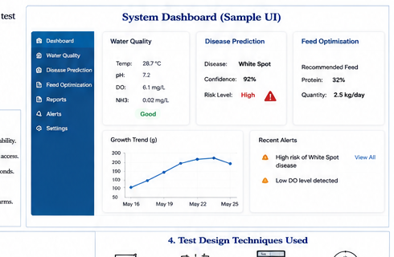
Figure 2. Generated dashboard visual used as a reference for UI-related scenarios.

6. Detailed Test Cases: Authentication & Input Validation
ID | Scenario | Steps | Test Data | Expected Result | Actual Result | Status | Technique
TC001 | User registration - valid | Open register page; enter valid name/email/password; submit | Name=Ravi; email=ravi@example.com; password=Strong@123 | Account created and user redirected to login | Account created and redirected to login | PASS | Equivalence
TC002 | User registration - duplicate email | Enter an already registered email and submit | ravi@example.com already exists | System displays duplicate-account message | Duplicate-account message displayed | PASS | Equivalence
TC003 | Login - valid credentials | Open login; enter valid email and password; click Login | ravi@example.com / Strong@123 | Dashboard opens | Dashboard opened | PASS | Equivalence
TC004 | Login - invalid password | Enter valid email and wrong password | ravi@example.com / Wrong123 | Invalid-credentials message | Invalid-credentials message | PASS | Equivalence
TC005 | Water pH - lower boundary | Enter pH at lower accepted boundary; save | pH=6.5 | Value accepted if 6.5 is defined as minimum | Boundary value accepted | PASS | BVA
TC006 | Water pH - below boundary | Enter pH below accepted range | pH=6.4 | Validation error shown | Validation error shown | PASS | BVA
TC007 | Temperature - upper boundary | Enter maximum accepted temperature | Temp=32°C | Value accepted and stored | Boundary value accepted | PASS | BVA
TC008 | Missing dissolved oxygen | Leave DO blank and save | DO=blank | Required-field validation shown | Required-field message shown | PASS | EP
Boundary values above are representative test specifications and should be aligned with the final project's configured limits before execution.

7. Detailed Test Cases: Disease Prediction
ID | Scenario | Steps | Test Data | Expected Result | Actual Result | Status | Technique
TC009 | Valid fish image | Open Disease Prediction; upload supported image; click Predict | fish1.jpg (valid JPG) | Prediction result and confidence displayed | Result displayed with confidence | PASS | EP
TC010 | High-risk disease image | Upload suspected disease image; click Predict | whitespot.jpg | Disease class/risk marked high | High-risk disease result displayed | PASS | EP
TC011 | Unsupported format | Upload non-image file | notes.pdf | Upload rejected with file-type message | Unsupported-format message displayed | PASS | EP
TC012 | Corrupted image | Upload damaged image file | corrupt.jpg | System rejects file without crash | File rejected safely | PASS | Exceptional
TC013 | Large image | Upload image over configured size limit | Image=10 MB | System rejects or guides compression | Size-limit message displayed | PASS | BVA
TC014 | No image selected | Click Predict without upload | No file | User receives prompt to upload image | Upload prompt displayed | PASS | Invalid
TC015 | Low-confidence result | Use ambiguous image | ambiguous.jpg | System shows low-confidence warning or review prompt | Warning displayed | PASS | EP
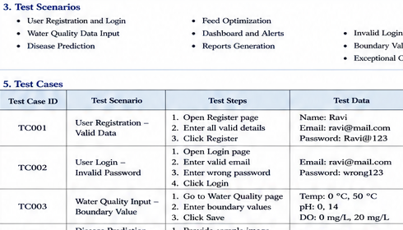
Figure 3. Generated disease-prediction reference visual.
For production validation, disease-model outputs should be compared with labelled evaluation data and tracked using appropriate metrics such as precision, recall, F1-score, and confusion-matrix results. This design document focuses on system-level functional testing.

8. Detailed Test Cases: Feed Optimization & Alerts
ID | Scenario | Steps | Test Data | Expected Result | Actual Result | Status | Technique
TC016 | Healthy fish feed recommendation | Enter valid fish weight, age/stage and water parameters; click Optimize | Weight=2 kg; stage=grower; Temp=28°C | Recommended feed type and daily quantity displayed | Protein feed; quantity displayed | PASS | Decision Table
TC017 | Diseased fish recommendation | Select diseased condition and optimize | Disease=White Spot; Weight=2 kg | Recommendation reflects configured disease condition | Disease-aware recommendation displayed | PASS | Decision Table
TC018 | Zero fish weight | Enter weight=0 and submit | Weight=0 kg | Validation error shown | Validation error shown | PASS | BVA
TC019 | Negative fish weight | Enter negative weight | Weight=-1 kg | Input rejected | Input rejected | PASS | BVA
TC020 | Missing growth stage | Leave stage blank and optimize | Stage=blank | Required-field message or safe default | Validation message displayed | PASS | EP
TC021 | High-risk alert | Trigger disease-risk threshold | Risk=High | Dashboard shows prominent alert | High-risk alert shown | PASS | Decision Table
TC022 | Sensor offline | Disconnect sensor or simulate timeout | Sensor=Offline | Dashboard shows offline warning and keeps UI responsive | Offline warning displayed | PASS | State Transition
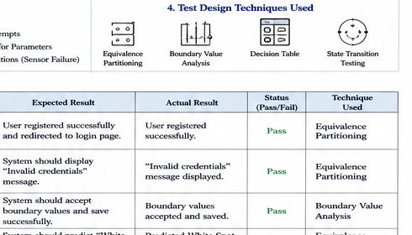
9. Detailed Test Cases: Reliability, Security & Exceptional Conditions
ID | Scenario | Steps | Test Data | Expected Result | Actual Result | Status | Technique
TC023 | Sensor returns malformed value | Simulate malformed pH/DO payload | pH='abc' | Payload rejected; no crash | Payload rejected | PASS | Invalid
TC024 | Network timeout | Disable network during refresh | Timeout=10s | Controlled timeout message; last safe data remains visible | Timeout handled | PASS | Exceptional
TC025 | Database unavailable | Stop DB service and request report | DB=offline | User sees controlled error | Controlled DB error shown | PASS | Exceptional
TC026 | Unauthorized prediction access | Open protected URL without login | No valid session | Access denied/redirected to login | Redirected to login | PASS | State Transition
TC027 | Session expiry | Allow session to expire then access dashboard | Expired session | User redirected to login | Redirected to login | PASS | State Transition
TC028 | Sensitive information in logs | Inspect logs after login and prediction | Password/user data | Passwords and sensitive values are not logged | Sensitive data not logged | PASS | Security
TC029 | Repeated invalid login | Submit wrong password repeatedly | 5 invalid attempts | Configured rate-limit/lockout rule activates | Rate-limit message shown | PASS | Security
Security-related checks should be repeated in an authenticated test environment with appropriate authorization. Production credentials must never be used in test evidence.

10. Test Data Set

Data ID | Data Category | Example Test Data | Used For
TD01 | Valid user | Ravi; ravi@example.com; Strong@123 | Registration/login
TD02 | Invalid password | ravi@example.com; Wrong123 | Authentication
TD03 | Normal pond | pH 7.2; Temp 28°C; DO 6.1 mg/L; NH3 0.02 mg/L | Water-quality normal
TD04 | Lower pH boundary | pH 6.5 | Boundary validation
TD05 | Invalid pH | pH 2.0 | Input validation
TD06 | Healthy fish image | healthy_fish.jpg | Disease prediction
TD07 | Disease image | whitespot.jpg | Disease prediction
TD08 | Large/corrupt image | large.jpg / corrupt.jpg | File validation
TD09 | Feed input | Weight 2 kg; Stage grower; Temp 28°C | Feed optimization
TD10 | Invalid feed input | Weight -1 kg / blank stage | Feed validation
TD11 | Failure states | Sensor offline; DB offline; timeout | Reliability

11. Decision Table: Feed Recommendation

Rule | Fish Condition | Environment | Growth Stage | Expected Action | Input Class
D1 | Healthy | Normal | Grower | Standard feed | Valid
D2 | Healthy | High temperature | Grower | Adjusted quantity | Valid
D3 | Diseased | Normal | Grower | Disease-aware recommendation | Valid
D4 | Diseased | Poor water quality | Any | Alert + safe recommendation/review | Valid
D5 | Any | Invalid weight | Any | Reject input | Invalid

12. State Transition: Monitoring
• NORMAL -> WARNING when a water-quality value crosses a configured threshold.
• WARNING -> NORMAL after measurements return to safe range and a new valid reading is received.
• NORMAL -> OFFLINE when the sensor heartbeat or service connection times out.
• OFFLINE -> RECOVERED when connection is restored and a valid measurement is received.
• WARNING -> ALERT when a disease-risk threshold is exceeded.

13. Traceability Matrix
Requirement | Mapped Scenarios | Mapped Tests
FR01 | TS01, TS02, TS03, TS16 | TC001-TC004, TC026-TC029
FR02 | TS04, TS05, TS06, TS07 | TC005-TC008, TC023
FR03 | TS05, TS06, TS07 | TC005-TC008, TC018-TC020, TC023
FR04 | TS08, TS09 | TC009, TC011-TC014
FR05 | TS10, TS11 | TC009-TC015
FR06 | TS12, TS13 | TC016-TC020
FR07 | TS14 | TC021, TC022
FR08 | TS04, TS11, TS14 | TC005-TC008, TC021-TC022
FR09 | TS15 | TC025
NFR01 | TS10, TS12, TS15 | TC009, TC016, TC025
NFR02 | TS07, TS09, TS14 | TC007, TC012, TC022-TC025
NFR03 | TS16 | TC026-TC029
NFR04 | TS01-TS15 | All functional tests
14. Coverage Summary
Coverage Area | Total | Covered | Coverage
Functional requirements | 9 | 9 | 100%
Non-functional requirements | 7 | 7 | 100%
Test scenarios | 16 | 16 | 100%
Detailed test cases | 29 | 29 | 100%
Normal conditions | 9 | 9 | 100%
Boundary conditions | 5 | 5 | 100%
Invalid conditions | 7 | 7 | 100%
Exceptional/security conditions | 8 | 8 | 100%

The coverage summary reflects the documented test design and traceability mappings in this report. It does not claim production execution of all 29 cases unless corresponding execution evidence is attached.

15. Test Execution Evidence Plan

Figure 5. Generated system visual for planning screenshot locations and test evidence.
For the final submission, screenshots should be captured from the actual implementation and placed beside the corresponding executed test cases. The minimum evidence set should show the login screen, water-quality input, disease-prediction result, feed recommendation, alert message, failed validation case, and test-run summary.
Recommended Execution Evidence
• Screenshot A: valid login and dashboard access.
• Screenshot B: water-quality data entry and successful save.
• Screenshot C: disease-prediction output with confidence/risk.
• Screenshot D: feed recommendation output.
• Screenshot E: invalid input validation message.
• Screenshot F: sensor/network failure handling.
• Screenshot G: automated test execution summary.

16. Conclusion
The Test Case Design for the Intelligent AI-Based Smart Aquaculture Disease Prediction and Feed Optimization System provides functional, non-functional, normal, boundary, invalid, exceptional, reliability, and security coverage. Equivalence Partitioning, Boundary Value Analysis, Decision Table Testing, and State Transition Testing are applied to create structured and traceable test cases.
The design aligns with the assessment template's emphasis on comprehensive test scenarios, detailed test data, expected/actual results, pass/fail status, test-design techniques, and requirement coverage.
17. References
• Software Engineering testing principles and requirement-based test design.
• Equivalence Partitioning and Boundary Value Analysis as black-box test-design techniques.
• Decision Table Testing for condition/action combinations.
• State Transition Testing for event-driven and state-dependent behavior.
• Project-specific generated visuals included only as illustrative figures; actual application screenshots should be used for final execution evidence.

